**Sri Lanka Institute of Information Technology**

Milestone 3

**User Experience Engineering – IT3050**

B.Sc. (Hons) in Information Technology

Group: SER026_WEEKEND

Sustainable Development Goal: Life Below Water

|  |  |
| --- | --- |
| **Student ID** | **Student Name** |
| IT20281564 | M.T Sanju |
| IT20039004 | H.C Liyanage |
| IT20047542 | W.M.K.K.B Walisundara |
| IT20206550 | K.I.K.R.D.N. Kandakkulama |

|  |  |  |
| --- | --- | --- |
| **IT20281564** | **Fall Point/Blocking** | **Customers requirement.** |
| 01  Fail – points / Blocking | I thought details must show after the login | The actual requirement of the customer is to view some details about the sea and oceans to get a brief idea. |
| 02  Fail – points / Blocking | I thought in home user should see the posts only. | The actual requirement of the customer is to view posts and save it. |
| 03  Fail – points / Blocking | I thought in home user should see the posts only. | The actual requirement of the customer is to view posts but user should be able to download the post in the PDF format. |

1. First User Flow - Manage Profile **–** IT20281564

**Updated user flow**

Showing description at the welcome page

Click on navigation button

Click on Profile

Change Details

Click on “Save”

End

Start

If user is logged in already

Login/ Sign in

Home

NO

Yes

Brief introduction about the sea and oceans

Adding save post option in the home page for the later reference

Click on navigation button

Click on Profile

Change Details

Click on “Save”

End

Start

Splash Screen

If user is logged in already

Login/ Sign in

NO

Yes

Save the posts in the home

Adding download post in the PDF format

Click on navigation button

Click on Profile

Change Details

Click on “Save”

End

Start

Splash Screen

If user is logged in already

Login/ Sign in

NO

Yes

Save the posts in the home

Click the download Button to download the post in PDF format

**IT20039004**

|  |  |  |
| --- | --- | --- |
| **IT20039004** | **Fall Point/Blocking** | **Customers requirement.** |
| 01  Fail – points / Blocking | I thought uploading research is enough with add. | The actual requirement of the customer is to add their profession when uploading research. |
| 02  Fail – points / Blocking | I thought that uploading article is enough. | But user thinks adding videos also interesting |
| 03  Fail – points / Blocking | I thought uploading articles, research and videos are enough. | The actual requirement of the user is to suggest new innovative ideas to readers. |

**Updated user flow**

**Newly added features**

**Add innovative ideas to benefit conserve marine eco system.**

**Add videos.**

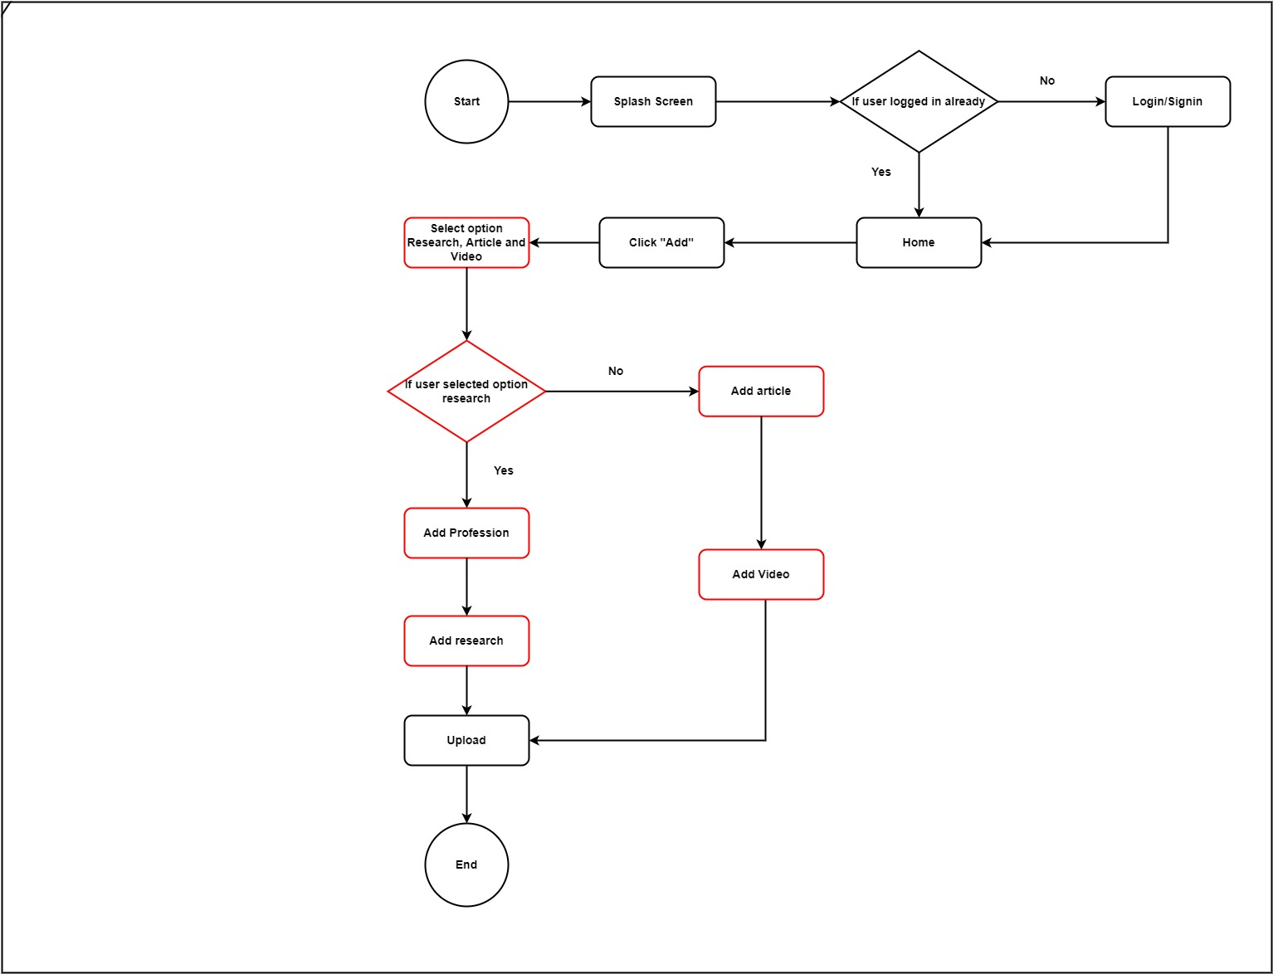

**IT20206550**

|  |  |  |
| --- | --- | --- |
| IT20206550 | Fall Point/Blocking | Customers requirement. |
| 01  Fail – points / Blocking | I thought that text comments are only enough for the, add comment flow | The actual requirements of adding comment that customer hopes to have feature to add image as a comment also. |
| 02  Fail – points / Blocking | I thought that, when we are adding comments there should be display the name of the customer who add the comment. | But sometimes customer think about their privacy. So, they want to choose whether they want to display name or not. |
| 03  Fail – points / Blocking | I thought its good to have button under the blog to navigate comments window. | But customers said its very useful if we are able to read other people’s comments under the post without clicking another button. |

**Updated user flow**

End

Yes

Select hide name toggle

Click on “Save”

NO

Select a post

Click on “Add comment”

Upload a comment

Click on “Upload”

If user select image comment

NO

If user select anonymous author

Select the upload image icon

Upload the Image

Start

Splash screen

If user is logged in already

Login/ Sign in

Home

NO

Yes

Yes

**Newly featured user flows**

**Rating a Blog.**

Start

Splash screen

If user is logged in already

Login/ Sign in

Home

NO

Yes

Select a post

Give a star rate / reacts to the blog

Save the rating

End

**Edit and delete comment**

View comments

Select your added comment

Edit /delete comment

Start

Splash screen

If user is logged in already

Login/ Sign in

Home

NO

Yes

Select a post

Edit /delete comment

Click on “Save”

End

**IT20047542**

|  |  |  |
| --- | --- | --- |
| IT20047542 | Fall Point/Blocking | Customers requirement. |
| 01  Fail – points / Blocking | When a researcher posts a blog, user cannot see the blog owner's details. | Diver wishes to support researchers in their work. After that, they can assist and provide them with fresh ideas. |
| 02  Fail – points / Blocking | Research is conducted in English. | Diver wants to read the blogs in several languages. |
| 03  Fail – points / Blocking | Users do not want to log in when seeing blogs. | Diver wants to view to blog in another language. |

**Updated user flow**

Yes

End

Request blog with new language

If want to view blog owner’ details

If want to view blog in another language

View contact details

Start

Splash screen

If user is logged in already

Login/ Sign in

Home

Search Blog by topic

Select a Blog

Read the Blog

Yes

Yes

NO

NO

Click on “Back”

Home

**Newly featured user flows**

**Add mark feature after reading**

End

NO

Yes

If want to view blog owner’ details

If want to view blog in another language

View contact details

Yes

NO

Click on “Back”

Home

Start

Splash screen

If user is logged in already

Login/ Sign in

Home

NO

Select a Blog

Read the Blog

Mark as read

Yes

Search Blog by topic

Request blog with new language

**Sorting the Blog / research Paper**

End

Request blog with new language

NO

Click on “Back”

Home

Start

Splash screen

If user is logged in already

Login/ Sign in

Home

NO

Search Blog by topic

Select a Blog

Read the Blog

If want to view blog owner’ details

If want to view blog in another language

View contact details

Yes

Yes

NO

Sort Blog by date